Fine-tune gen AI outputs by adjusting tool settings
Have you ever noticed that the same prompt can produce different results? That’s because generative AI tools use a mix of learned patterns and probability to decide what to say next. It’s a bit like rolling dice to choose a word, but what if you could influence that dice roll?
Some tools, like Google AI Studio, provide you with a control panel that allows you to adjust these settings, often called sampling parameters. Think of them as the guardrails that guide the AI's word choices. Knowing when and how to fine-tune these settings can help you generate better, more tailored results. In this reading, you'll learn about the three main parameters you'll encounter when using gen AI: temperature, top-k, and top-p.
Temperature
Temperature is the most common and impactful setting on your control panel. Think of it as the AI's creativity dial:
- Dialing up the temperature produces more creative and unexpected responses. This is perfect for artistic tasks like brainstorming ideas or writing a short story.
- Dialing down the temperature produces more predictable and consistent output. This is useful for tasks that require accurate, factual responses, like summarizing a report or generating a timeline.
For example, imagine prompting an AI with the start of a sentence: “This morning, I went to the…” The AI must now decide on the next word that best completes the sentence. Based on its training, it creates a ranked list of the most likely options, each with a probability score:
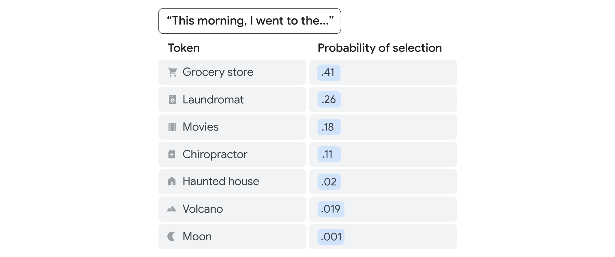
Temperature directly influences how the AI uses these probability scores. As the illustration shows, a low temperature setting makes the AI conservative, making it pick the highest-scoring, most obvious word—in this case, "grocery store." In contrast, a high temperature setting encourages the AI to take risks, giving lower-scoring, more unexpected words like “haunted house” or “moon” a chance to be selected.
Fine-tuning with top-p and top-k
While temperature acts as the main creativity dial, two other settings help you fine-tune the pool of words the AI tool can choose from: top-k and top-p.
Think of them as focus dials. They work by creating a smaller, more relevant list of potential words before the temperature setting makes its creative choice.
- Top-k sets a fixed number of words the tool can choose from. For example, setting top-k to 10 instructs the tool to choose a word only from the top 10 most likely options on its list.
- Top-p sets a dynamic number of words the tool can choose from. It instructs the tool to automatically shrink or grow its list of options based on how predictable the next word is. For example, setting a high top-p (e.g., p=0.9) acts as a quality filter, instructing the tool to consider only the most probable choices.
For most use cases, top-p is the recommended setting to adjust because it will adapt to the context of the situation. The key difference to remember is that top-k uses a fixed-size list of choices, while top-p uses a flexible-size list.
Pro tip: When using top-p, it is best practice to leave top-k at its default setting.
Recipes for Success
Knowing what each setting does is helpful, but using them together can be very useful. Here are two common recipes for success.
Recipe 1: Focused Analysis
- Task: Generate answers that are factual, consistent, and predictable.
- Use Cases: Summarizing reports, extracting data insights, writing technical documentation, or generating code.
- Settings:
  - Temperature: Low (e.g., 0.1 to 0.4)
  - Top-k or Top-p: Leave at default, as the low temperature already makes the output very focused.
Recipe 2: Creative Brainstorming
- Task: Generate surprising, diverse, or innovative output.
- Use Cases: Brainstorming new ideas, drafting marketing materials, or writing fictional stories.
- Settings:
  - Temperature: High (e.g., 0.8 to 1.0)
  - Top-k or Top-p: A high value (like 0.95 for top-p) can be helpful here to give the AI tool creative freedom while still filtering out irrelevant options.
Note: With all three settings, a high score can spark surprising insights, but they also increase the chances of generating inaccurate information, or hallucinations. Remember to always review and fact-check the output, especially when using creative configurations.
A great prompt is just the starting point—not the destination. The key is to find the right balance between creative and predictable answers. Temperature is your creativity dial, while top-p and top-k help you keep that creativity focused. By learning to use these simple controls, you can go beyond great prompting to generate better results for any task.
- Top-k:
Top-k is a parameter that limits the AI's choices to a fixed number of the most likely options, allowing for more focused and relevant outputs.
- Top-p:
Top-p is a dynamic parameter that adjusts the number of options based on the predictability of the next word, providing a flexible approach to filtering choices.
- Temperature:
Temperature is a setting that controls the creativity of the AI's responses, with higher values leading to more creative and unexpected outputs, while lower values yield more predictable results.

